Top of Form



Bottom of Form

RICH CHOCOLATE TART WITH SALT FLAKES

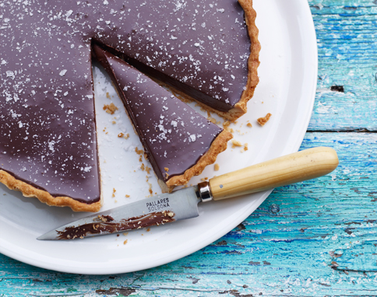

**dessert recipes | serves 4-6**

*You can make the pastry for this, if you like, but ready-made is easier.*  
  
1. Preheat the oven to 180/gas 4. Roll out the pastry and use it to line a 23cm greased tart tin. Cover with baking paper, fill with dried beans and bake blind for 10-15 minutes, then remove the beans and bake again for 15 minutes until golden.  
2. Put the cream, sugar and salt in a pan and bring to the boil. Remove as soon as the mixture boils up. With the pan off the heat, add the butter and chocolate. Stir until blended.  
3. Take a couple of minutes for a breather, then stir in the milk. Keep stirring till it's shiny. Pour into the tart shell and leave at room temperature for 2 hours to set.  
4. Sprinkle the salt flakes lightly all over, then serve with crème fraîche or ice cream.

**Recipe** Kevin Gould   
**Photo** Con Poulos  
  
http://www.jamieoliver.com/core/images/jamie-mag/sml_2619.jpg  
from Issue 13

INGREDIENTS

• 300ml double cream  
• 2 tsp caster sugar  
• A pinch of fine sea salt  
• 50g unsalted butter, softened  
• 200g 70% cocoa cook’s chocolate, broken into small pieces  
• 50ml whole milk  
• 375g ready-made shortcrust pastry  
• Sea salt flakes and crème fraîche